Thevenin and Norton Equivalent Circuits

1. **Table**

|  |  |  |  |  |  |  |  |  |
| --- | --- | --- | --- | --- | --- | --- | --- | --- |
| **Sl. No.** | **Rl (Ohm)** | **Original Circuit** | | **Thevinin’s** | | **Rth=RN**  **(Ohm)** | **Norton’s** | |
| **VAB(V)** | **IAB(A)** | **Vth(V)** | **IAB(A)** | **ISC(A)** | **IAB(A)** |
| 1. | **25** | **183.594** | **7.344** | **587.5** | **7.344** | **55** | **10.682** | **7.344** |
| **2.** | **50** | **279.762** | **5.595** | **587.5** | **5.595** | **55** | **10.682** | **5.595** |
| **3.** | **100** | **379.032** | **3.79** | **587.5** | **3.79** | **55** | **10.682** | **3.79** |

1. Thevenin’s Circuit:



Norton’s Circuit:



In Norton’s equivalent circuit, current source along with parallel resistance is used while in thevenin’s equivalent circuit voltage source with series resistance is used.

Norton’s equivalent circuit is the source transformed circuit of thevenin’s equivalent circuit.

1. **Load current vs load resistance graph using parameter sweep** 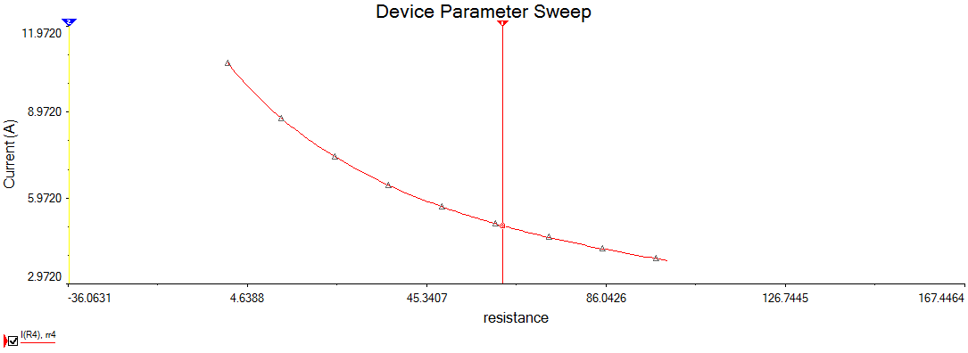

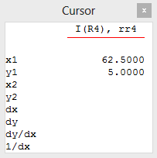

So, for Rl = 62.5 Ohms, load current = 5A

1. **Load power vs load resistance graph using parameter sweep** 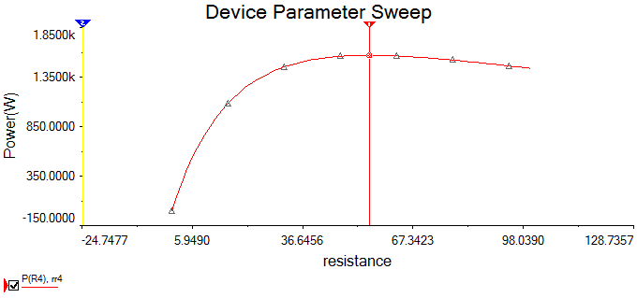

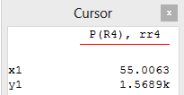

Thus, for max power across load, load resistance is 55.0063 Ohms which is equal to the Rth.

1. **Max power transfer theorem states that, for max power across the load, the load resistance must be equal to the Thevenin’s resistance.**

Where Thevenin’s resistance is the resistance measured between A and B with load disconnected and voltage sources are replaced by their internal resistance and current sources are open circuited.